# Change client settings

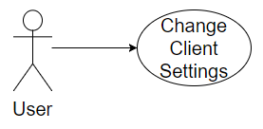

## Characteristic Information

|  |  |
| --- | --- |
| Superior business process: | Process-ID: refers to section 2.5.1 (business processes)> |
| Goal: | Set the color  Set the volume  Set options like you want |
| Precondition: | The client needs to be started  The options button must be clicked |
| Postcondition: | The client is designed like the user wants |
| Involved User: | The User choses the options he likes |
| Triggering Event: | The User clickes the button “options” in his own userinterface |

## GUI to call the use case

| Input field | Valid input |
| --- | --- |

## GUIs for the standard use

| Step | User | Activity |
| --- | --- | --- |
| 1 | User | Start program |
| 2 | User | Hide the friendlist |
| 3 | User | Click the settings button |

## Scenarios for non-standard uses (bad cases or work around cases)

## GUIs for the non-standard uses

## Workflow

## Open Points